ESP32 + INMP441 Microphone Hardware Documentation
Pocket drone activity detection prototype, two microphone I2S wiring
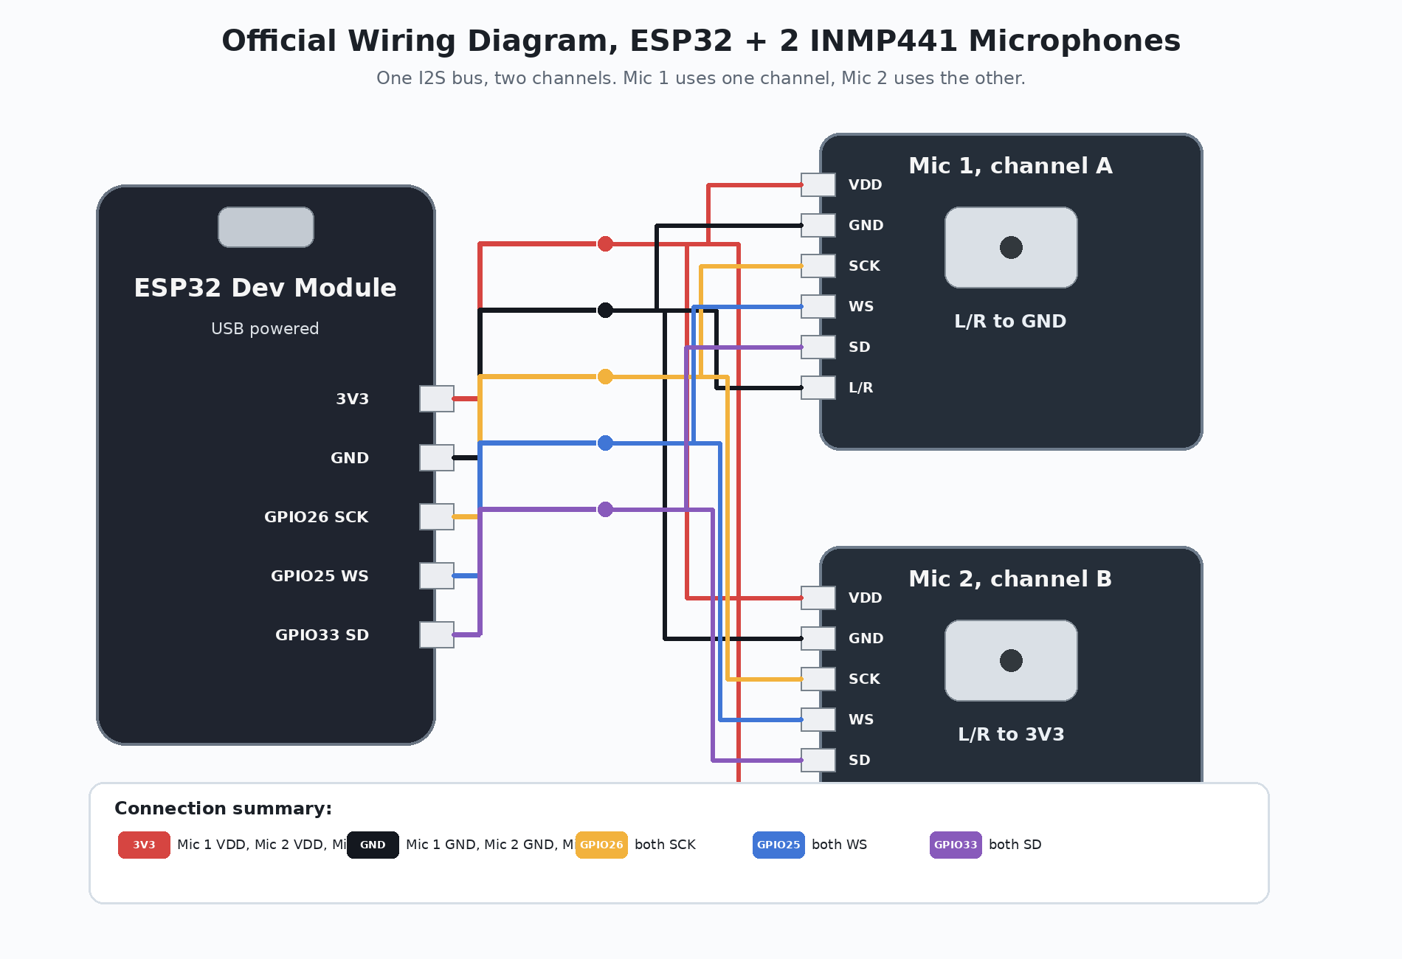
Figure 1. Official two microphone wiring diagram for one ESP32 I2S bus.
Prototype status
This document locks the working hardware layout before adding the vibrator alert or a third and fourth microphone. The goal is stable two microphone sound sensing first.

1. Prototype Hardware Goal
The first reliable prototype uses one ESP32 and two INMP441 I2S digital microphones. The two microphones share one I2S bus, but each microphone uses a different audio channel. This gives better detection strength while still keeping left and right information for later direction estimation.
Part | Quantity | Purpose
ESP32 Dev Module | 1 | Reads I2S audio data and later controls vibration alert.
INMP441 I2S microphones | 2 | Detects sound activity and gives left/right comparison.
Soldered Y harness | 1 set | Shares VDD, GND, SCK, WS, and SD between two microphones.
Vibrator motor and driver | Later | Not included in this wiring stage. Add only after sound sensing is stable.

Current build rule
Do not add the vibrator motor or more microphones until the two INMP441 microphones are stable in the Serial Plotter. More hardware before stable signals will make debugging much harder.

2. INMP441 Pin Labels and Meaning
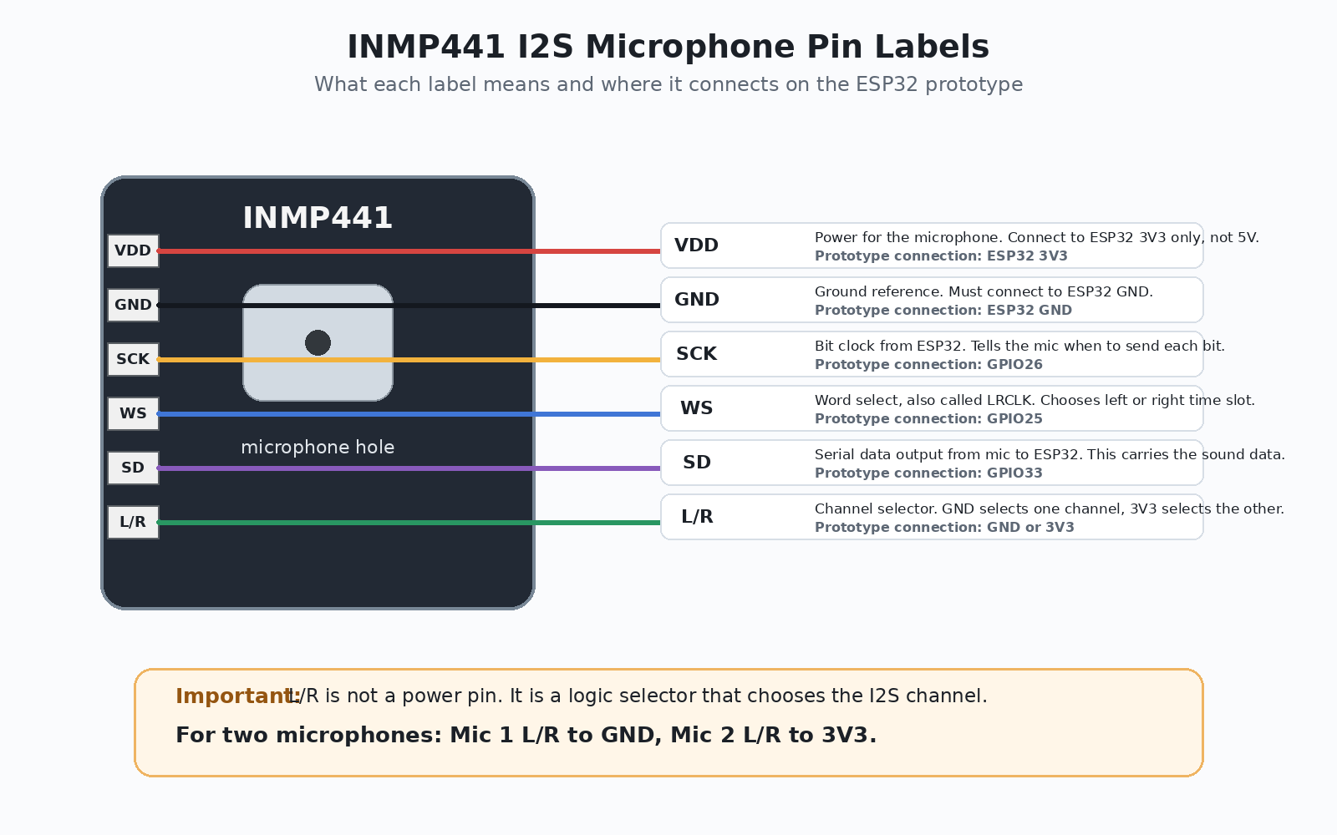
Figure 2. INMP441 labels, pin functions, and prototype connection points.
The important idea is that not all pins are the same type. VDD and GND power the microphone. SCK and WS are timing signals from the ESP32. SD is the microphone data output. L/R is a channel selector, not a power pin.

3. Final Two Microphone Wiring Table
ESP32 pin | Mic 1 pin | Mic 2 pin | Why this connection is used
3V3 | VDD | VDD and L/R | Powers both microphones. Also sets Mic 2 to the other I2S channel.
GND | GND and L/R | GND | Common reference. Also sets Mic 1 to the first I2S channel.
GPIO26 | SCK | SCK | Bit clock. ESP32 tells both mics when to send bits.
GPIO25 | WS | WS | Word select. ESP32 alternates left and right time slots.
GPIO33 | SD | SD | Shared data line. Mic 1 and Mic 2 send data in different time slots.
Correct L/R rule: Mic 1 L/R goes to GND. Mic 2 L/R goes to 3V3. Do not connect both L/R pins together.

4. Why L/R Needs GND on One Mic and 3V3 on the Other
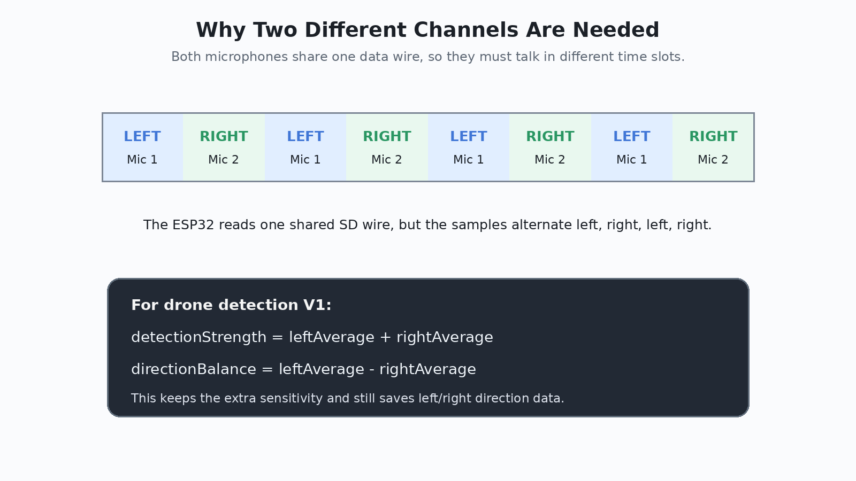
Figure 3. One I2S bus uses alternating left and right time slots.
One I2S bus has two audio time slots, commonly called left and right. With one microphone, either channel can work if the code reads the correct channel. With two microphones on the same SD wire, the microphones must use different channels so they do not talk over each other.
Wiring | Result | Use case
Mic 1 L/R to GND, Mic 2 L/R to 3V3 | Correct. Two separate channels. | Use this.
Both L/R to GND | Wrong. Both try to use the same channel. | Avoid.
Both L/R floating | Wrong. Random unstable readings. | Avoid.
One mic only, L/R to GND or 3V3 | Acceptable if the code reads the matching channel. | Useful for testing one mic.

5. Soldered Y Harness Plan
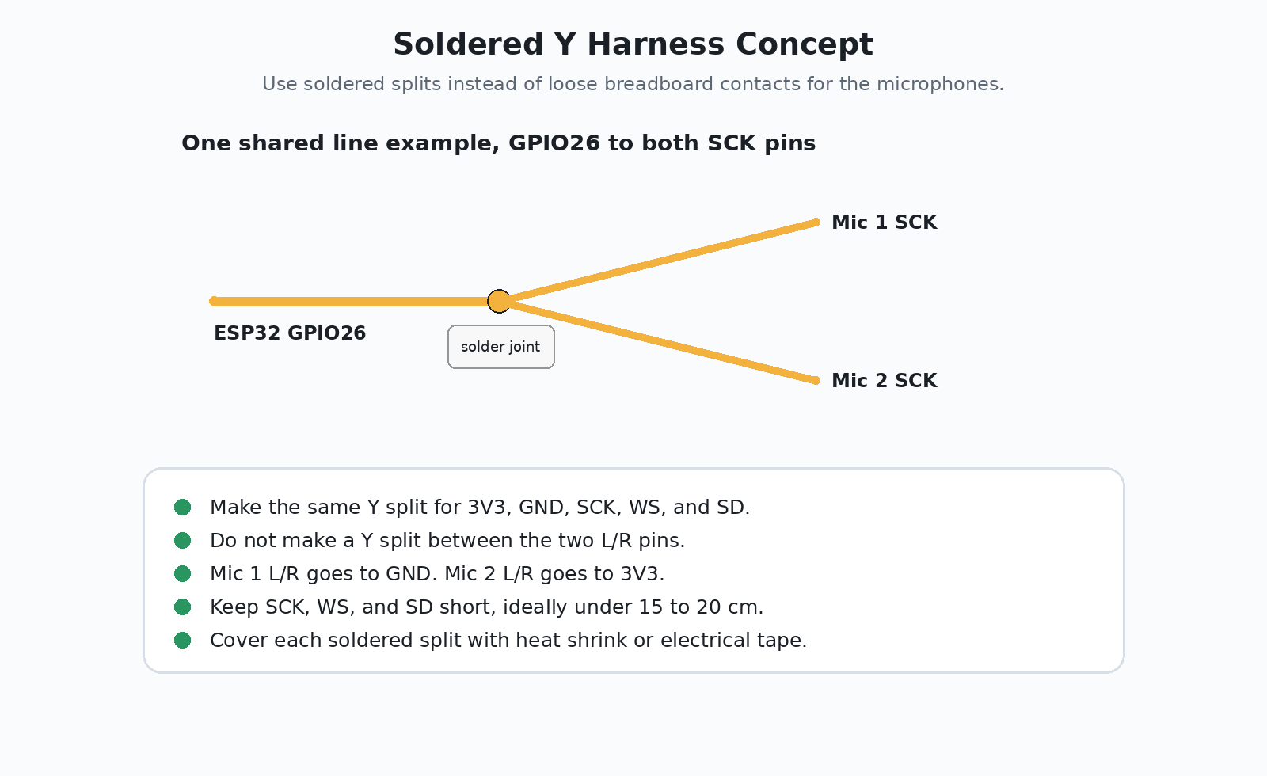
Figure 4. Soldered Y harness concept for shared I2S and power lines.
The breadboard was loose during testing, so the microphone harness should be soldered. Five lines are shared by both microphones: VDD, GND, SCK, WS, and SD. The L/R pins are separate because they choose the channel.
Soldering checks before USB power
Use the multimeter in continuity mode. 3V3 to GND must not beep. SCK to GND must not beep. WS to GND must not beep. SD to GND must not beep. Mic 1 L/R to GND should beep. Mic 2 L/R to 3V3 should beep.

6. ESP32 Prototype Picture Reference
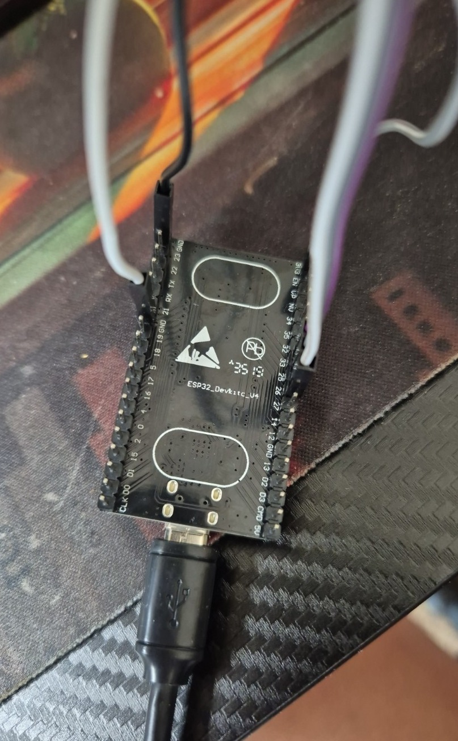
Figure 5. Your ESP32 Dev Module test setup. Use the labels printed on the board to find 3V3, GND, GPIO25, GPIO26, and GPIO33.
On your ESP32, the exact printed label may appear as 25, 26, 33, GND, and 3V3. The number is the GPIO number. Do not use 5V or VIN for the INMP441 microphones.

7. Hardware Test Plan
Test | Expected result | Meaning
Quiet room, no touching wires | Low stable line. No random big spikes. | Wiring is stable.
Clap near Mic 1 | One channel spikes higher. | Mic 1 channel is working.
Clap near Mic 2 | Other channel spikes higher. | Mic 2 channel is working.
Music or fan sound | Both channels rise continuously while sound is present. | Mics detect continuous sound.
Move one wire gently | Graph should not go crazy. | If it spikes, that wire or solder joint is weak.

8. Drone Detection Logic for This Hardware
For detection, do not force both microphones onto one channel. Keep two channels, then combine them in software. This keeps the extra sensitivity and preserves direction information.
leftAverage = sound level from Mic 1
rightAverage = sound level from Mic 2
detectionStrength = leftAverage + rightAverage
directionBalance = leftAverage - rightAverage
Meaning
High detectionStrength means possible drone, motor, fan, or propeller-like sound. directionBalance shows which side is louder. For V1, use detectionStrength for alert. Use directionBalance later for left/right direction.

9. Do Not Do These
- Do not connect INMP441 VDD to 5V or VIN.
- Do not leave L/R floating.
- Do not connect both L/R pins together.
- Do not add the vibrator motor directly to an ESP32 GPIO pin.
- Do not add microphones 3 and 4 until the two microphone setup is stable.

